**CITY UNIVERSITY**



**Hand Gesture Nurse Call System For Patient Using GSM**

[A report submitted to the department of Computer Science & Engineering, City University in partial fulfillment of the requirements for the award of degree of Bachelor of Science in Computer Science and Engineering.]

**CITY UNIVERSITY**

**DHAKA, BANGLADESH**

**MARCH, 2020**

**CITY UNIVERSITY**



**Submitted by**

**Md Ariful Hasan**

**ID: 11328351**

**Batch: 28th**

**Department of Computer Science & Engineering**

**&**

**Golam Dostogir Shaon**

**ID: 141352005**

**Batch: 35th**

**Department of Computer Science & Engineering**

**CITY UNIVERSITY**

**DHAKA, BANGLADESH**

**MARCH, 2020**

**CITY UNIVERSITY**



**Supervised by**

**Sharmin Akter**

**Lecturer,**

**Department of Computer Science & Engineering**

**CITY UNIVERSITY**

**DHAKA, BANGLADESH**

**MARCH, 2020**

**CITY UNIVERSITY**



**CERTIFICATE**

This is to certify that the project titled “**Hand Gesture Nurse Calling System For Patient Using GSM**” submitted to **CITY UNIVERSITY** in partial fulfillment of the requirements forthe award of the degree of Computer Science and Engineering is the bona-fide qualification record of the project work done by **Md Ariful Hasan, ID : 11328351**  and **Golam Dostagir Shaon, ID : 141352005**. The project report has been carried out under by guidance andis a record of work carried out successfully during August-2019 to February-2020. To the best of my knowledge this project has not performed anywhere for a degree.

**Approved By:**

|  |
| --- |
| Sharmin Akter (Supervisor)  Lecturer, |
| Department of CSE |

**CITY UNIVERSITY**



**DECLARATION**

We do hereby solemnly declare that, the work presented here in this project report has been carried out by us and has not been previously submitted to any University/ /College/ Organization for award of any degree. We hereby ensure that the works that has been presented here does not breach any existing copyright.

We further undertake to indemnify the university against any loss or damage arising from breach of the foregoing obligation.

Md Ariful Hasan (11328351)

&

Golam Dostogir Shaon (141352005)

**CITY UNIVERSITY**

**DHAKA, BANGLADESH**

**MARCH, 2020**

**ACKNOWLEDGEMENT**

Firstly, we like to express our utmost gratitude to Allah, without his mercy and blessing this work could not been possible to carry out. Then we would like to thanks our honorable supervisor **Sharmin Akter**, Lecturer, Department of Computer Science and Engineering, City University, for her valuable guidance, encouragement and friendly co-operation in all possible ways throughout this project work.

We would also like to thanks Professor **Dr. Md. Matiur Rahman Miah,** Dean, Faculty of Science and Engineering, for his endless support.

We would like to give special thanks and all credits of the project to our honorable teacher **Md. Safaet Hossain**, Associate professor and Head of the Department ofComputer Science & Engineering, for his helps in various ways from CSE department during his busy schedule.

**Name of students**

Md Ariful Hasan

ID :11328351

Golam Dostagir Shaon

ID :141352005

**CITY UNIVERSITY**

**DHAKA, BANGLADESH**

**MARCH, 2020**

**DEDICATION**

*This project is dedicated to all the people of our country they are suffering in medical assistant problem and our parents, our lovely teachers and our well-wishers who are taking a lot of pains for the progress in our lives for their sacrifices, blessings and constant prayers for our advancement.*

**CITY UNIVERSITY**

**DHAKA, BANGLADESH**

**MARCH, 2020**

Abstract

According the World Health Organization (WHO) reports in 2010, there are more than 17,000,000 people infected with stroke yearly in all countries of the world as a result of the brain injury and prevent damage to the blood supply to the brain which leads to the injury that the patient is suffering of total paralysis or paraplegia. The researchers in the field of technology asserted to find solutions for Stroke patients who cannot move parts of their bodies due to injury , help to create an easy of stroke patients to perform daily functions easily using Hand Gesture . The Hand Gesture (HG) has become an alternative to traditional input devices such as a mouse and keyboard and etc. The proposed model is built by using supervised neural networks (SNN). The idea of this algorithm is reading hand signals (HS) by high resolution camera and processed by the computer after supervised neural networks applied.

Nurse Call systems are very important for any medical center / ICU center / hospital, thus affecting indirectly the patient’s life. The basic idea of this paper is to design and implement a complete wireless nurse call system in the hospital, displaying the patient room number on a desktop computer LCD. Our proposed system implements a smart controller and several wireless switches using RF technology to continuously monitor and display the state of any room / patient / medical help or assistance needed, in order to provide fast and respectable medical service without any human errors or medical assistance delay, which could occur at any instant of time during system preparation or installation. Our system has succeeded in monitoring up to 5 rooms at the same time collecting real-time data as a prototype. It can be extended to up to 254 monitoring points.

In this paper, a new design of GSM based nurse calling system is discussed which is based on plug and play concept. The system is developed by using low-cost components and open source material, Arduino and GSM Module as a hardware while Processing language is used to design the user interface program. The wireless network is implemented via low power GSM Module to guarantee the security between the slave and master nodes. The graphical user interface is easy to use and uncomplicated; it simulates the hospital rooms and bathrooms.

Background Study

Nurse Call System is one of the essential things that patients need. Usually each patient’s bed has a buzzer sys- tem. Nurses and other health personnel immediately at- tend the patient as soon as they hear the ringing. A nurse regular call system is intended for routine communication between each patient and the nursing staff. Activation of the system at a patient's station will sound a repeating audible signal at the nurse station. It should be noted that sometimes patients’ requests are very critical, and lack of attention to the smallest request can be hazardous or cause damages to the patient. This issue is vital for intensive care unit (ICU). Although the precise numbers of patient transfers to ICU are not available in the literature, one can assume that at least 15% of ICU patients are transported during a year . On the other hand, Hospitalization in the ICU for patient and their family is a stressful phenomenon and patient connection with ventilator increases this stress. Statistics show half of the ICU patients are treated with mechanical ventilation. In the United States of America 1.5 million patients are under mechanical ventilation and hospitalized in ICU, and it has been shown that 55.5% of ICU.

Contents

CHAPTER 1 13

1.1 Introduction 13

1.2 Artificial Neural Network 14

1.3 OBJECTIVE 15

1.4 Methodology 16

1.5 Working Principle 17

1.5.1 Review of Previous Work 18

1.5.2 PROPOSED SYSTEM ARCHITECTURE 18

1.6 Research Motivation 18

1.6.1 Material and Methods: 18

CHAPTER 2 20

2.1 System design 20

2.2 System Block Diagram 21

2.3 System Circuit Diagram: 21

CHAPTER 3 23

3.1 List of Component with Price 23

3.2 Arduino Nano Microcontroller Board 24

3.2.1 Defining Arduino Nano 24

3.2.2 Arduino Architecture 24

3.2.3 Arduino Pin Diagram 25

3.3 How to program an Arduino? 26

3.3.1 Five Steps to program an Arduino: 26

3.3.2 Few of basic Adruino functions: 27

3.3.3 How to Design our own Arduino? 27

3.4 Three axis accelerometer 28

3.4.1 Features 28

3.4.2 Applications 28

3.4.3 General description 28

3.4.4 THEORY OF OPERATION 29

3.4.5 MECHANICAL SENSOR 29

3.4.6 PERFORMANCE 29

3.4.7 APPLICATIONS INFORMATION 30

3.5 Transformer 30

3.5.1 Working of this Transformer 31

3.6 Diode 31

3.6.1 Characteristics 32

3.7 Full-Wave Rectifiers 33

3.7.1 Working of a Bridge Rectifier 33

3.8 Capacitor 34

3.8.1 Theory of Operation 35

3.9 Voltage Regulator 36

3.9.1 Voltage Regulators Output Voltages 36

3.10 SIM 800l GSM Module: 37

3.10.1 Introduction 37

3.10.2 SIM800LOverview 37

3.10.3 SIM800L Key Features: 38

3.10.5 Coding schemes and maximum net data rates over air interface 40

3.10.6 Operating Mode: 40

3.10.7 Functional Diagram 41

3.10.8 Pin Description 42

3.10.10 Power Supply 44

3.10.11 Recommended Zener diode 44

3.10.12 Power supply pin 45

3.10.13 Monitoring Power Supply 46

3.10.14 Power on/down Scenarios 46

3.11 LCD Display 46

3.11.1 How LCDs are Constructed? 47

3.11.3 How LCDs Work? 48

3.11.4 Advantages of an LCD’s: 49

3.11.5 Disadvantages of an LCD’s 49

3.11.6 Applications of Liquid Crystal Display 49

3.12 Main Features of the System 50

CHAPTER 4 50

4.1 Results 50

4.2 DISCUSSION 51

4.3 Advantages 52

4.4Limitations 53

4.5 Applications 53

CHAPTER 5 54

5.1Conclusions 54

5.2 Future Work 55

# CHAPTER 1

## Introduction

A sign language is a language which, uses manual communication and body language to convey meaning. This can include combining hand shapes, orientation and movement of the hands, arms or body, and facial expressions to fluidly express a speaker's thoughts . So ,its important language for Persons with disabilities . Patients monitoring techniques image processing and computer vision to produce understanding sign .It keep track of various hands parameters and provides data to analysis it and monitor system. It is depend on gestures language Interpreter of the patients (i.e interaction descriptor ).This utility system have general facility due to its depend on monitoring the patients in different regions. If a patient ask to eat or something else , the system helps him to achieve what he wants, even if this request out of reach .It is used to express of patient wishes . This method is the easiest way to help the patients and what they need , when the patient unable to walk due to stroke, and what feeling in complete paralysis, except his hands. Then the system completely depend on hands movements. The details of system consist of digital camera connects with active system to monitor closely the SP. The idea of the system is to monitor the patient's hands. Basically, the movement of the patient will be interpreted and compared with the database , depend on special movement build in the system. The system reject any gestures not exist (contrary to the rules). The sign language is a language which, uses manual communication and body language to convey meaning. This can include combining hand shapes, orientation and movement of the hands, arms or body, and facial expressions to fluidly express a speaker's thoughts . So ,its important language for Persons with disabilities . Patients monitoring techniques image processing and computer vision to produce understanding sign .It keep track of various hands parameters and provides data to analysis it and monitor system. It is depend on gestures language Interpreter of the patients (i.e interaction descriptor ).This utility system have general facility due to its depend on monitoring the patients in different regions. If a patient ask to eat or something else , the system helps him to achieve what he wants, even if this request out of reach .It is used to express of patient wishes . This method is the easiest way to help the patients and what they need , when the patient unable to walk due to stroke, and what feeling in complete paralysis, except his hands. Then the system completely depend on hands movements. The details of system consist of digital camera connects with active system to monitor closely the SP. The idea of the system is to monitor the patient's hands. Basically, the movement of the patient will be interpreted and compared with the database , depend on special movement build in the system. The system reject any gestures not exist (contrary to the rules). The error message are displayed when the patient's gesture is out of system rules

A wireless nurse call system is a new advancement technology which holds the latest cutting edge wireless methods at its core. This enables patients to use them in such an easy and comfortable way, receiving its medical assistance quickly. Since it does not need the usage of any wires like old versions of nurse call systems, it becomes very simple for hospital staff to deploy and use it within minutes. Wireless nurse call systems are scalable from a few beds to so many. No future maintenance is needed, as the medical assistant could affect directly the patient health in the hospital.

In the third world countries, Libya as an example, normal buildings transform into asylums and hospitals is common; these buildings are usually designed for general purposes and not as hospitals, where they lacked the infrastructure should be considered when designing health facilities, such as electrical wiring, water pipes, and gas pipes. To install some systems often is needed extensions of electrical wires through walls and floors, and this may add high costs or impair or change the design of the building. Perhaps, replacing the wiring system by wireless system is the best solution for this problem. In additional, the world is moving trend to use wireless communication, and to use nano-scale devices . Wireless Sensor Networks (WSNs) today become the most popular and common in the real world. WSN is a network made up of a set of sensors (nodes) deployed in the geographic area, to collect data from the environment, and to send the collected data to the main station, Typically through the wireless channels . Sensors may be used in fire monitoring in forests , or to measure the temperature , or even water monitoring or any type of sensors. "Fig. 1" shows a typical Wireless Sensors Network (WSN). The proposed system is based on the nurse calling system design; the system relies on the use of wireless communication between parts of the system rather than the wired system. As a result, the cost of the system is reduced and complexities of wires are canceled as well as the aesthetic view. The rest of this paper is organized as follows. Section II explains the proposed system architecture. The system design is illustrated in section III. Section IV shows the system hardware design. The system software design is explained in section V. Finally, the conclusions of this paper are in the last section.

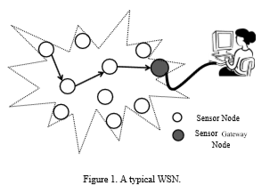

This has become so important, ever since quality and reliability have deemed so critical in patient and life safety according to the regulations imposed by the Federal Food, Drug, and Cosmetic Act (FDA), as well as other medical standard codes such as the European Standard (ISO 7369) and the American Standard (NFPA 99) . The main configuration of our proposed system has been applied to five hospital patient rooms as shown typically in Figure. It particularly features the following:

1) Arduino Nano board which could be battery operated.

2) Wireless Transceiver serial UART (for the RF operation) located in each patient room.

3) Push button switches .

4) Raspberry Pi2 Model B for the monitoring station.

5) LCD computer screen for the final data display.

## 

## 1.2 Artificial Neural Network

ANN is a computational model which similar to the way human brain works. Human brain is consist of billions of neurons interconnected by synapses, the neural networks can be form as a network of computational nodes connected with each other through links. This networks needs to be trained continuously with set of data before it can be used to produce the desired output. Because of neural network are adaptive nature , the structure of these networks can changed easily depend specific information that that enter to the network during the learning phase. The links these networks are

assigned during training phase . ANN are used to model complex relation between input signals and output signals .Neural networks can find various patterns in input signals. neural networks can be very helpful in modeling complex systems due to its flexible construct ,that is to be very difficult in traditional modeling. ANN are very useful in image processing fields ,speech recognition , pattern recognition and various that requirement information extraction. neural network can be classify into two main categories : the input and the output. ANN is consist of many nodes or neurons called processing elements (PE) and interconnect between them, set of nodes represent the input nodes of neural network that take data from external environment .A set of nodes represent output nodes that produce intermediary hidden nodes or not. These hidden nodes connect with each other by links called connections, connect with input or output nodes or other hidden nodes.

Any ANN consist of 3 main parts:

(1) Input layer nodes

(2) Output layer nodes

(3) Hidden layer nodes (internal nodes)

. Figure (1). show the block diagram of neural network with 12 nodes: 3 nodes in the input layer, 7 nodes in the hidden layer and 2 nodes in the output layer. The neural network can be used in actual production environment . The process of training of artificial neural networks is called learning of neural network, which is generally done by one of three ways.

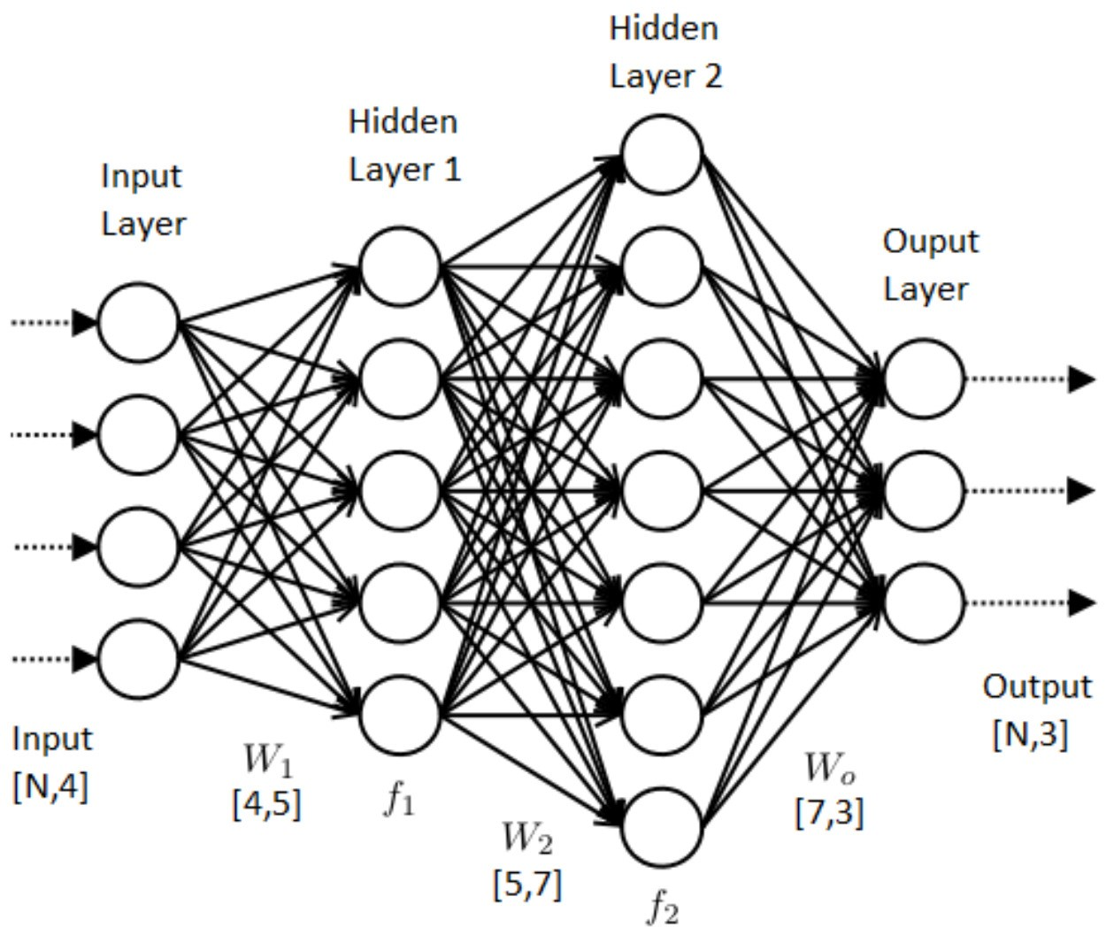

Fig 1: Neural Network

## 1.3 Objective

Main objective of this project are:

1. Increase patient service
2. Easily found called patient.
3. Easily found nurse at any time
4. Decrease patient harassment.
5. Inform authority about his staff behavior.
6. And easily found dr./ nurse using emergency button

## 1.4 Methodology

System detection and recognition of HG is a classification system which distinguishes HG of allowed gestures of SP. This methodology uses processing of digital image technique for the classification purpose. The input system is specific HG Images saved in private database which are in digital format. This database can be add new images of HG by agreement of doctor according patients need . This system depends on the denoise (noise reduction or removal) images, where the images are processed in advance , even before adding them to the assigned database . The proposed system depend on GUI or called vision interface.

Vision interfaces are based on feasibility and popularity because the computer machine is able to communicate with user using camera or webcam. In this way, the user can be able to give commands (hands commands or gestures) to the computer by just showing some actions (hand movements) in front of the webcam without typing keyboard and clicking mouse button. Then , the interaction is occur between user and computer .

User interface for the hand gesture recognition was developed using MATLAB GUI (Graphical User Interface). During run the application handles video streaming from the webcam and timing of frame processing. Frame rate can exceed 20 fps which is more plenty for reliable human gesture detection. Hand movements are the key points in hand gesture recognition modeling in the human hand model. This approach is based detection and recognition on applying a learning model to reconstruct the hand model.

1. Information was collected from related reference books and websites to find out the possible improvement.
2. It was designed on paper on the basis of background research.
3. Components were collected from local electronic market.
4. Worked on building the project and experimental verification.

## 1.5 Working Principle

In this project we used 3 axis accelerometer, Operational Amplifier, step down transformer ,LCD, Arduino NANO ,GSM Module ,Fan, LED, Buzzer ,Temperature sensor,12 V battery, Power switch, capacitor ,Variable resistor,. At first we use step down transformer, for 220v convert to 10-12 v .Then DC Battery connected with it .Then we can source in circuit by using a voltage regulator at 5 v .it just like Vcc .Then we connected Vcc at Arduino 5V pin and GND at GND pin .Temperature sensor connect to A0 pin of arduino. Here we used a variable for set room temperature. Emergency calling pin switch connect to pin no A-3. When create an emergency situation then patient's relatives can press emergency button. Bed 1 calling button connect to pin no A-7. Bed 2 calling button connect to pin no A-6.Bed 3 calling button connect to pin no A-5. Bed 4 calling button connect to pin no A-4. GSM module connect to tx, rx pin of arduino. Here we use a fan that work depend on temperature. This temperature based fan connects to pin no D-3. 16x2 LCD display are connect to pin no D-12 to D-7. And buzzer also connect to pin no D-13. When bed 1 patient or patients relative press on the button that stand beside the bed then bed 1 calling… message show on screen and buzzer generate alarm for call and GSM module send message over the phone number that given in program. When bed 2 patient or patients relative press on the button that stand beside the bed then bed 2 calling… message show on screen and buzzer generate alarm for call and GSM module send message over the phone number that given in program. When bed 3 patient or patients relative press on the button that stand beside the bed then bed 3 calling… message show on screen and buzzer generate alarm for call and GSM module send message over the phone number that given in program. When bed 4 patient or patients relative press on the button that stand beside the bed then bed 4 calling… message show on screen and buzzer generate alarm for call and GSM module send message over the phone number that given in program. And When patient or patients relative press emergency the then emergency calling… message show on screen and buzzer generate alarm for call and GSM module send message over the phone number that given in program.

### 1.5.1 Review of Previous Work

1. Most investigators have designed a simple device by using wires, buzzers and LEDs, besides the old technology of switches and/or seven segments displays as shown in Figure

2. Previous devices needed many wire connections for each bed and room door light. They were also very difficult to install, and the site preparation was involved.

3. Previous devices were difficult to be interfaced with computers so as to perform full monitoring without human intervention .

4. Installation and site preparation costs were excessive, as the system needed scheduled maintenance

5. Since previous devices were not interfaced with computers, no data could be stored to support the analysis of patient and nurse behaviors.

6. Elementary faults like wires cut from switches, light emitting diode malfunction, bulb failure, and human error were prevalent. Our proposed system is intended to address all these weaknesses in a workable way to support high quality and reliability for life safety according to the international standards in the medical field .

### 1.5.2 PROPOSED SYSTEM ARCHITECTURE

The proposed system architecture is shown in "Fig. 2". The figure explains the main idea of the system where nursing staff can reply to the patient by knowing his room and his bed number via an easy graphical computer interface. The proposed system uses simple (WSN) and can be expanded. In this project do not use the sensors to monitor the environment or temperature measurement or other functions that can be used for it, just its use a signal coming from the push button. The architecture of the system is based on wireless communication and (plug and play), this allows to expand the network by adding rooms or beds. The new bed is given an address and this address is added to Processing program to access the wireless network.

## 1.6 Research Motivation

Ordinary nurse call systems are insufficient for customer satisfaction to provide safe and comfortable technology for patients, residents, and their families. A wired system requires up to 24 wires per room, thus generating spaghetti wiring, which in turn leads to increasing difficulties during installation, besides scheduled and unscheduled maintenance. Additionally, these traditional systems are incapable of storing data regarding both patient and nurse behaviors, resulting in human resource allocation with no data backup. Fitting a nurse call system can often be disruptive, time consuming, and expensive. However, this will no more become a problem with wireless nurse call systems

### 1.6.1 Material and Methods:

Hardware Material The necessary hardware for our prototype consists of the following elements

1) Several power supply types to meet the DC voltage needs, as shown in Figure 3a for the Arduino Nano board and in Figure 3b for the Raspberry Pi2 Model B.

2) Arduino – Nano Board, as shown in Figure 4.

5) Wiring and connectors for the Printing Circuit Boards, as shown in Figure 7.

6) Normal Push Button switches and toggles.

7) Variable switches, light emitting diode, resistors, and a buzzer (speaker) [10,11].

8) LCD Monitor screen.

# CHAPTER 2

## 2.1 System design

The system simply consists of two main parts as in "Fig. 3", the master and slave parts. The master part is located in the main nursing room, and the slave part is near the patient's bed (each bed has its own device). The master part consists of: the microcontroller (Arduino UNO) connected to the wireless module, two LEDS (green & red) and push button and a computer device. The slave part consists of: the microcontroller (Arduino NANO) connected to the wireless module, two LEDS (green & red) and push button, as shown in "Fig. 3".

In the normal case, the green LEDs at patient and nursing room is on, but when patient pressed the push button, the red LED is on and green LED is off. Then the controller that is located at the patient's bed communicates wirelessly to the master part that is located in the nursing room using the wireless module. The master recognizes special addresses of slaves, and open a channel of communication between them. According to a unique code that the slave part has sent, the computer device with the interface shows the room and bed of the

patient. The application is installed in the computer of nursing room identifies the address and the code of the patient. The program interface can show the room number and a bed in which to a help is needed. When the mouse clicks on the image of bed in the program interface, the system is informed that the request of calling is responding and the system returns to the normal case. In additional, the master part can communicate with more than one patient at the same time.

## 2.2 System Block Diagram

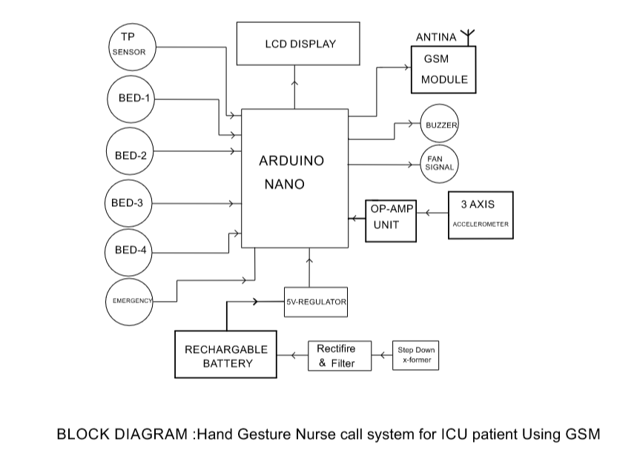

## 2.3 System Circuit Diagram:

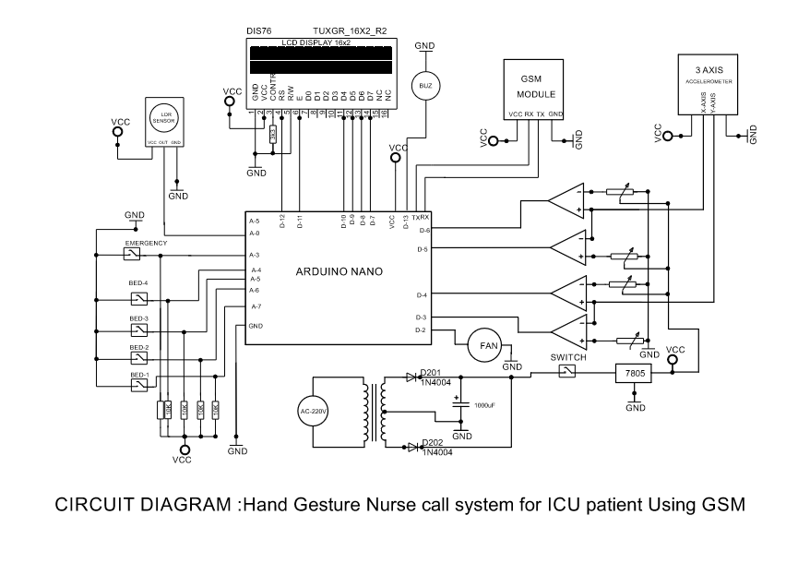

# CHAPTER 3

## 3.1 List of Component with Price

|  |  |  |  |
| --- | --- | --- | --- |
| SLNo | Component Name | Quantity | Price |
| 1 | ARDUINO NANO | 1 | 450 |
| 2 | 16X2 LCD | 1 | 300 |
| 4 | GSM MODULE | 1 | 500 |
| 5 | Step Down X-former | 2 | 100 |
| 7 | 3 AXIS ACCELEROMETER | 1 | 400 |
| 9 | 7805 Regulator | 4 | 20 |
| 10 | Capacitor 122MFD/35V | 8 | 50 |
| 11 | PUSHSWITCH | 10 | 40 |
| 12 | Power Switch | 2 | 40 |
| 14 | FAN | 2 | 100 |
| 15 | Some Resister |  | 20 |
| 16 | Connector | 1 | 20 |
| 17 | IC Bess | 2 | 50 |
| **Total Price** | | | **2290** |

**3.2 Arduino Nano Microcontroller Board**

### 3.2.1 Defining Arduino Nano

An Arduino is actually a microcontroller based kit which can be either used directly by purchasing from the vendor or can be made at home using the components, owing to its open source hardware feature. It is basically used in communications and in controlling or operating many devices. It was founded by Massimo Banzi and David Cuartielles in 2005.

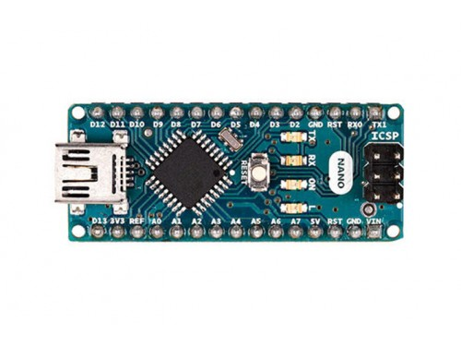

FIG:ARDUINO

3.2.2 Arduino Architecture:

Arduino’s processor basically uses the Harvard architecture where the program code and program data have separate memory. It consists of two memories- Program memory and the data memory.The code is stored in the flash program memory, whereas the data is stored in the data memory. The Atmega328 has 32 KB of flash memory for storing code (of which 0.5 KB is used for the bootloader), 2 KB of SRAM and 1 KB of EEPROM and operates with a clock speed of 16MHz.

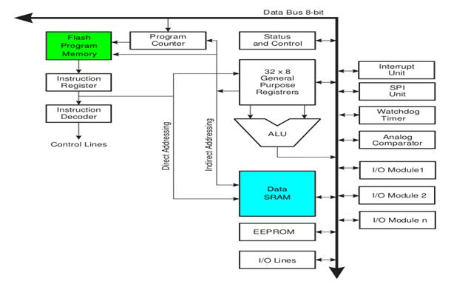

### 3.2.3 Arduino Pin Diagram

A typical example of Arduino board is Arduino Uno. It consists of ATmega328- a 28 pin microcontroller.

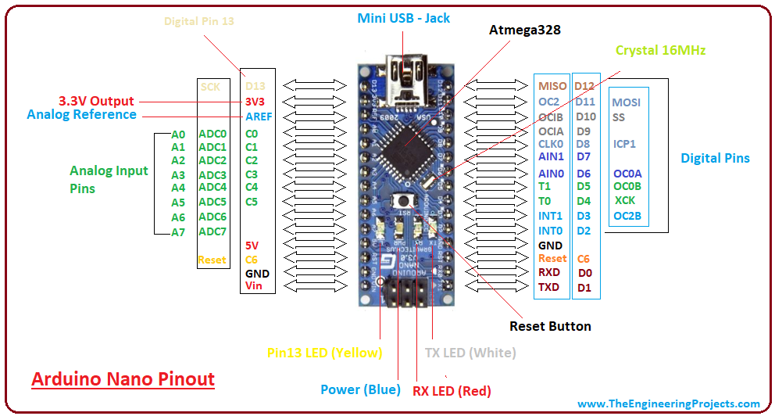

Power Jack:  Arduino can be power either from the pc through a USB or through external source like adaptor or a battery. It can operate on a external supply of 7 to 12V. Power can be applied externally through the pin Vin or by giving voltage reference through the IORef pin.

Digital Inputs: It consists of 14 digital inputs/output pins, each of which provide or take up 40mA current. Some of them have special functions like pins 0 and 1, which act as Rx and Tx respectively , for serial communication, pins 2 and 3-which are external interrupts, pins 3,5,6,9,11 which provides pwm output and pin 13 where LED is connected.

Analog inputs: It has 6 analog input/output pins, each providing a resolution of 10 bits.

ARef: It provides reference to the analog inputs

Reset: It resets the microcontroller when low.

## 3.3 How to program an Arduino?

The most important advantage with Arduino is the programs can be directly loaded to the device without requiring any hardware programmer to burn the program.

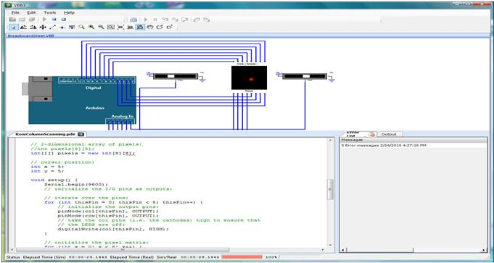

This is done because of the presence of the 0.5KB of Boot loader which allows the program to be burned into the circuit. All we have to do is to download the Arduino software and writing the code.

The Arduino tool window consists of the toolbar with the buttons like verify, upload, new, open, save, serial monitor. It also consists of a text editor to write the code, a message area which displays the feedback like showing the errors, the text console which displays the output and a series of menus like the File, Edit, Tools

### 3.3.1 Five Steps to program an Arduino:

Programs written in Arduino are known as sketches. A basic sketch consists of 3 parts

1. Declaration of Variables  
2. Initialization: It is written in the setup () function.  
3. Control code: It is written in the loop () function.

The sketch is saved with .ino extension. Any operations like verifying, opening a sketch, saving a sketch can be done using the buttons on the toolbar or using the tool menu.

The sketch should be stored in the sketchbook directory.

Chose the proper board from the tools menu and the serial port numbers.

Click on the upload button or chose upload from the tools menu. Thus the code is uploaded by the bootloader onto the microcontroller.

### 3.3.2 Few of basic Adruino functions:

digital Read(pin): Reads the digital value at the given pin.

digital Write(pin, value): Writes the digital value to the given pin.

pin Mode(pin, mode): Sets the pin to input or output mode.

analog Read(pin): Reads and returns the value.

analog Write(pin, value): Writes the value to that pin.

serial. begin(baud rate): Sets the beginning of serial communication by setting the bit rate.

### 3.3.3 How to Design our own Arduino?

We can also design our own Arduino by following the schematic given by the Arduino vendor and also available at the websites. All we need are the following components- A breadboard, a led, a power jack, a IC socket, a microcontroller, few resistors, 2 regulators, 2 capacitors.

The IC socket and the power jack are mounted on the board.

Add the 5v and 3.3v regulator circuits using the combinations of regulators and capacitors.

Add proper power connections to the microcontroller pins.

Connect the reset pin of the IC socket to a 10K resistor.

Connect the crystal oscillators to pins 9 and 10

Connect the led to the appropriate pin.

Mount the female headers onto the board and connect them to the respective pins on the chip.

Mount the row of 6 male headers, which can be used as an alternative to upload programs.

Upload the program on the Microcontroller of the readymade Adruino and then pry it off and place back on the user kit.

**7 Reasons why Arduino is being preferred these days**

It is inexpensive

It comes with an open source hardware feature which enables users to develop their own kit using Already available one as a reference source.

The Arduino software is compatible with all types of operating systems like Windows, Linux, and Macintosh etc.

It also comes with open source software feature which enables experienced software developers to use the Arduino code to merge with the existing programming language libraries and can be extended and modified.

It is easy to use for beginners.

We can develop an Arduino based project which can be completely stand alone or projects which involve direct communication with the software loaded in the computer.

It comes with an easy provision of connecting with the CPU of the computer using serial communication over USB as it contains built in power and reset circuitry.

## 3.4 Three axis accelerometer

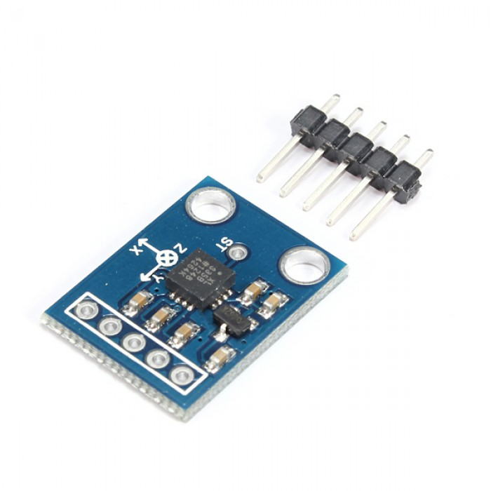

### 3.4.1 Features

3-axis sensing Small, low profile package 4 mm × 4 mm × 1.45 mm LFCSP Low power : 350 μA (typical) Single-supply operation: 1.8 V to 3.6 V 10,000 g shock survival Excellent temperature stability BW adjustment with a single capacitor per axis RoHS/WEEE lead-free compliant

### 3.4.2 Applications

Cost sensitive, low power, motion- and tilt-sensing applications Mobile devices Gaming systems Disk drive protection Image stabilization Sports and health devices

### 3.4.3 General description

The ADXL335 is a small, thin, low power, complete 3-axis accel-erometer with signal conditioned voltage outputs. The product measures acceleration with a minimum full-scale range of ±3 g. It can measure the static acceleration of gravity in tilt-sensing applications, as well as dynamic acceleration resulting from motion, shock, or vibration. The user selects the bandwidth of the accelerometer using the CX, CY, and CZ capacitors at the XOUT, YOUT, and ZOUT pins. Bandwidths can be selected to suit the application, with a range of 0.5 Hz to 1600 Hz for the X and Y axes, and a range of 0.5 Hz to 550 Hz for the Z axis. The ADXL335 is available in a small, low profile, 4 mm × 4 mm × 1.45 mm, 16-lead, plastic lead frame chip scale package (LFCSP_LQ

### 3.4.4 Theory of operation

The ADXL335 is a complete 3-axis acceleration measurement system. The ADXL335 has a measurement range of ±3 g mini-mum. It contains a polysilicon surface-micromachined sensor and signal conditioning circuitry to implement an open-loop acceleration measurement architecture. The output signals are analog voltages that are proportional to acceleration. The accelerometer can measure the static acceleration of gravity in tilt-sensing applications as well as dynamic acceleration resulting from motion, shock, or vibration. The sensor is a polysilicon surface micromachined structure built on top of a silicon wafer. Polysilicon springs suspend the structure over the surface of the wafer and provide a resistance against acceleration forces. Deflection of the structure is measured using a differential capacitor that consists of independent fixed plates and plates attached to the moving mass. The fixed plates are driven by 180° out-of-phase square waves. Acceleration deflects the moving mass and unbalances the differential capacitor resulting in a sensor output whose amplitude is proportional to acceleration. Phase-sensitive demodulation techniques are then used to determine the magnitude and direction of the acceleration. The demodulator output is amplified and brought off-chip through a 32 kΩ resistor. The user then sets the signal bandwidth of the device by adding a capacitor. This filtering improves measurement resolution and helps prevent aliasing.

### 3.4.5 Mechanical sensor

The ADXL335 uses a single structure for sensing the X, Y, and Z axes. As a result, the three axes’ sense directions are highly orthogonal and have little cross-axis sensitivity. Mechanical misalignment of the sensor die to the package is the chief source of cross-axis sensitivity. Mechanical misalignment can, of course, be calibrated out at the system level.

### 3.4.6 Performance

Rather than using additional temperature compensation circui-try, innovative design techniques ensure that high performance is built in to the ADXL335. As a result, there is no quantization error or nonmonotonic behavior, and temperature hysteresis is very low (typically less than 3 mg over the −25°C to +70°C temperature range).

### 3.4.7 Applications information

#### 3.4.7.1 Power supply decoupling

For most applications, a single 0.1 μF capacitor, CDC, placed close to the ADXL335 supply pins adequately decouples the accelerometer from noise on the power supply. However, in applications where noise is present at the 50 kHz internal clock frequency (or any harmonic thereof ), additional care in power supply bypassing is required because this noise can cause errors in acceleration measurement. If additional decoupling is needed, a 100 Ω (or smaller) resistor or ferrite bead can be inserted in the supply line. Additionally, a larger bulk bypass capacitor (1 μF or greater) can be added in parallel to CDC. Ensure that the connection from the ADXL335 ground to the power supply ground is low impedance because noise transmitted through ground has a similar effect to noise transmitted through VS.

#### 3.4.7.2 Power Supply

A power supply is an electronic device that supplies electric energy to an electrical load. The primary function of a power supply is to convert one form of electrical energy to another. As a result, power supplies are sometimes referred to as electric power converters. Some power supplies are discrete, stand-alone devices, whereas others are built into larger devices along with their loads. Examples of the latter include power supplies found in desktop computers and consumer electronics devices. The source of this power can come from different source like the main AC voltage ,a battery or even from a renewable power source like solar panel wind turbine or fuel cell to name just a few. The most common source of power is usually the main AC.



Fig. 3.3 AC-DC Power Supply & Circuit Diagram.

## 

## 3.5 Transformer

A transformer is a device consisting of two closely coupled coils called primary and secondary coils. An AC voltages applied to the primary appears across the secondary with a voltage multiplication proportion to the turn ratio of the transformer and a current multiplication inversely proportional to the turn ratio power is conserved

turn ration = VP/VS=NP/Ns and power out = power in or Vs

### 3.5.1 Working of this Transformer

The two voltages, between line 1 and neutral and between neutral and line 2 can be named as VA and VB respectively. Then the mathematical relation of these two voltages shows that they are dependent upon the primary voltage as well as the turn ration of the transformer.

VA = (NA / NP) * VP

VB = (NB / NP) * VP

One thing that should be noted here is that both the outputs VA and VB respectively are equal in magnitude but opposite in direction, which means that they are 180 degrees out of phase with each other. For this purpose, we also use a full wave rectifier with a center tapped transformer, to make both the voltages in phase with each other.

## 

## 3.6 Diode

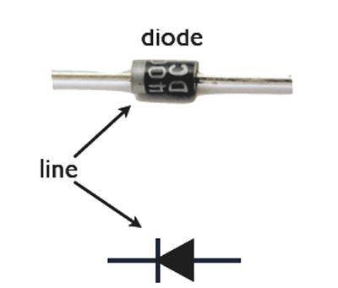

Fig. 3.5 Diode and symbol

The term diode usually implies a small signal device with current typically in the milliamp range. A semiconductor diode consists of a PN unction and has two (2) terminals, an anode (+) and cathode (-) current flows from anode to cathode within the diode. Diodes are semiconductor device that might be described as passing current in one direction only. The latter part of that statement applies equally vacuum tube diodes. Diodes however are far more extremely versatile in fact. Diode can be used as rectifier, voltage regulators, turning devices in radio frequency tuned circuit, frequency multiplying device in radio frequency circuit, mixing devices application or can be used to make logic decision in digital circuit.

### 3.6.1 Characteristics

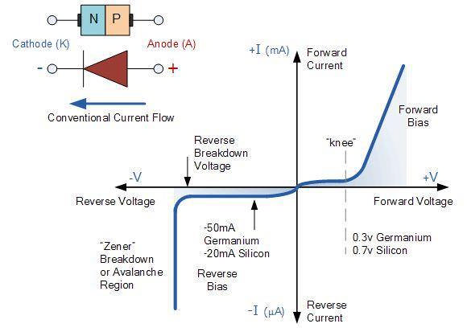

There are two operating regions and three possible “biasing” conditions for the standard Junction Diode and these are:

1. Zero Bias – No external voltage potential is applied to the PN junction Diode

2. Reverse Bias – The voltage potential is connected negative, (-ve) to the P type material and positive, (+ve) to the N-type material across the diode which has the effect of Increasing the PN junction diode’s width.

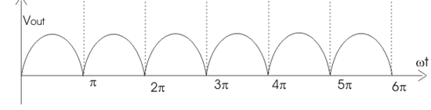3. Forward Bias – The voltage potential is connected positive, (+ve) to the P type material and negative, (-ve) to the N-type material across the diode which has the effect of Decreasing the PN junction diodes width.

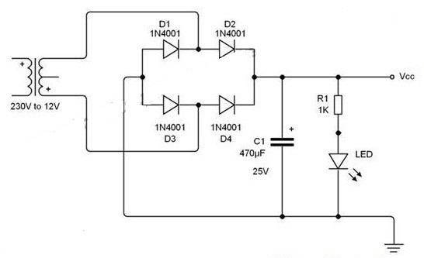

Fig:. .Bridge rectifier circuit

Fig. 3.9 Pulsating DC output

## 3.7 Full-Wave Rectifiers

A rectifier is an electronic circuit that converts AC voltage to DC voltage. It can be implemented using a capacitor diode combination. The unique property of diodes, permitting the current to flow in a single direction is utilized in here. It converts an ac voltage into a pulsating dc voltage using both half cycles of the applied ac voltage. Bridge rectifier is a full wave rectifier circuit using the combination of four diodes to form a bridge. It has the advantage that it converts both the half cycles of AC input into DC output.

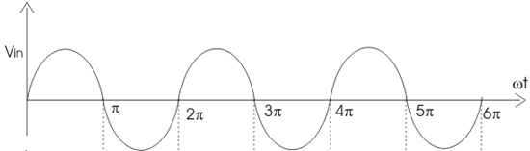

Fig. 3.8 Input sine wave

### 3.7.1 Working of a Bridge Rectifier

•During the positive half cycle of secondary voltage, diodes D2 and D3 are forward biased and diodes D1 and D4 are reverse biased. Now the current flows through D2– >Load–>D3.

•During the negative half cycle of the secondary voltage, diodes D1 and D4 are forward biased and rectifier diodes D2 and D3 are reverse biased. Now the current flows through D4–>Load>D1 .

•In both the cycles, load current flows in the same direction. Hence we get a pulsating DC voltage as shown in fig (3.5,3.6).

•Addition of a capacitor at the output converts the pulsating DC voltage to fixed DC voltage.

•Up to a time period of t=1s input voltage is increasing, so the capacitor charges up to peak value of the input. After t=1s input starts to decrease, then the voltage across the capacitor reverse biases the diodes D2 and D4 and therefore it will not conduct. Now capacitor discharges through the load, then voltage across the capacitor decreases.

•When the peak voltage exceeds the capacitor voltage, diodes D2 or D4 forward biases and as aresult capacitor again charges to the peak value. This process continues. Hence we get almost smooth DC voltage as shown in fig (3.7).

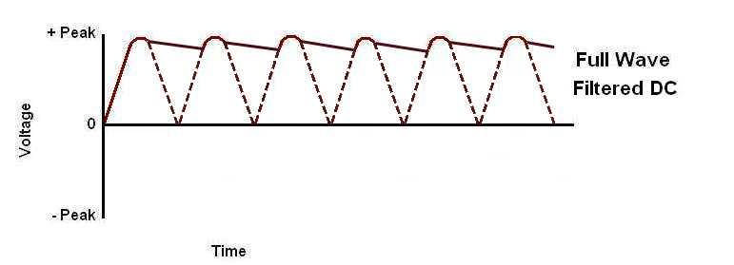

Fig. 3.10 Filtered output

## 3.8 Capacitor

Capacitor is a passive two-terminal electrical component used to store energy in an electric field. The forms of practical capacitors vary widely, but all contain at least two conductors separated by a non-conductor. Capacitors used as parts of electrical systems, for example consist of metal soils separated by a layer of insulating film. A capacitor is passive electronic component consisting of a pair of conductors separated by a dielectric (insulator) when there is a potential difference (voltage) across the detected on one plate and negative charge on the other plate. Energy is stored in the electrostatic field and is measured in farads.

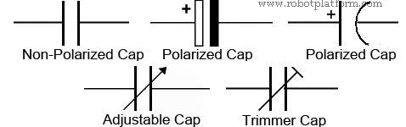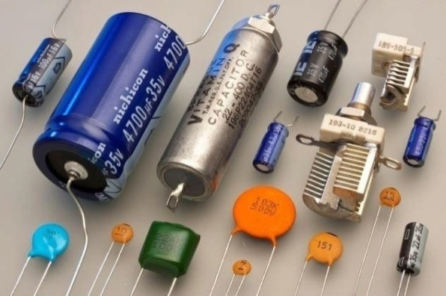

Fig. 3.11 Capacitors & Capacitor symbols.

### 3.8.1 Theory of Operation

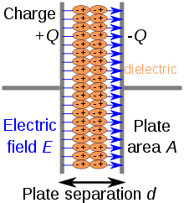

Fig 3.12 Internal constriction of capacitors

A capacitor consists of two conductors separated by a non-conductive region. The non-conductive region is called the dielectric. In simpler terms, the dielectric is just an electrical insulator. Examples of dielectric media are glass, air, paper, vacuum, and even a semiconductor depletion region chemically identical to the conductors. A capacitor is assumed to be self-contained and isolated, with no net electric charge and no influence from any external electric field. The conductors thus hold equal and opposite charges on their facing surfaces, and the dielectric develops an electric field. In SI units, a capacitance of one farad means that one coulomb of charge on each conductor causes a voltage of one volt across the device.

An ideal capacitor is wholly characterized by a constant capacitance C, defined as the ratio of charge ±Q on each conductor to the voltage V between them:

𝑪=𝑸𝑽

Because the conductors (or plates) are close together, the opposite charges on the conductors attract one another due to their electric fields, allowing the capacitor to store more charge for a given voltage than if the conductors were separated, giving

the capacitor a large capacitance.

Sometimes charge build-up affects the capacitor mechanically, causing its capacitance to vary. In this case, capacitance is defined in terms of incremental changes:

𝑪=𝒅𝑸𝒅𝑽

## 3.9 Voltage Regulator

A voltageregulator is a system designed to automatically maintain a constant voltage level. A voltage regulator may use a simple feed-forward design or may include negative feedback. It may use an electromechanical mechanism, or electronic components.

### 

### 3.9.1 Voltage Regulators Output Voltages

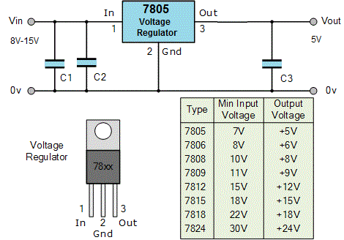

Fig. 3.13 Voltage regulator output voltages.

## 

## 3.10 SIM 800l GSM Module:

### 3.10.1 Introduction

This document describes SIM800L hardware interface in great detail. This document can help user to quickly understand SIM800L interface specifications, electrical and mechanical details. With the help of this document and other SIM800L application notes, user guide, users can use SIM800L to design various applications quickly

### 3.10.2 SIM800LOverview

SIM800L is a quad-band GSM/GPRS module, that works on frequencies GSM850MHz, EGSM900MHz, DCS1800MHz and PCS1900MHz. SIM800L features GPRS multi-slot class 12/ class 10 (optional) and supports the GPRS coding schemes CS-1, CS-2, CS-3 and CS-4.

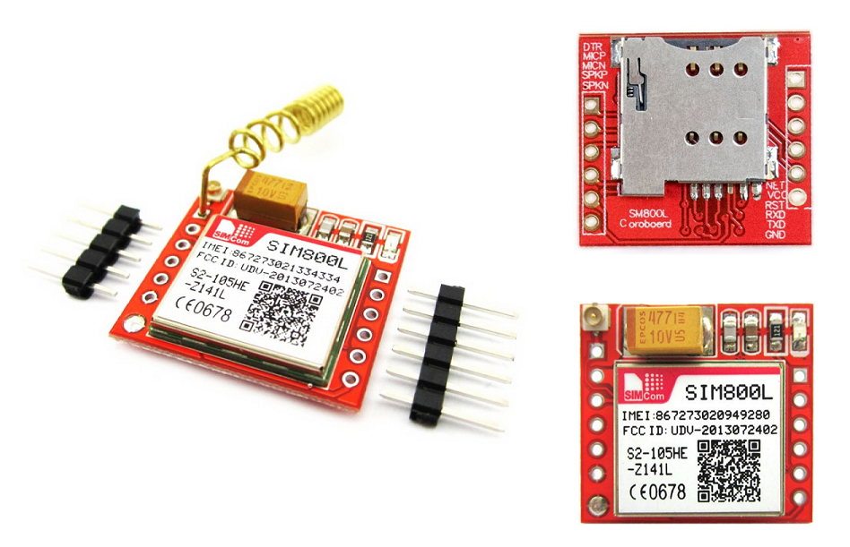

With a tiny configuration of 15.8*17.8*2.4mm, SIM800L can meet almost all the space requirements in user applications, such as smart phone, PDA and other mobile devices.

SIM800L has 88pin pads of LGA packaging, and provides all hardware interfaces between the module and customers’ boards.

* + Support 5*5*2keypads
  + One full modem serial port, user can configure two serial ports
  + One USB, the USB interfaces can debug, download software
  + Audio channel which includes two microphone input; a receiver output and a speaker output
  + Programmable general purpose input and output.
  + A SIM card interface
  + Support FM
  + Support one PWM

SIM800L is designed with power saving technique so that the current consumption is as low as 0.7mA in sleep mode.

### 3.10.3 SIM800L Key Features:

|  |  |
| --- | --- |
| **Feature** | **Implementation** |
| Power supply | 3.4V ~4.4V |
| Power saving | typical power consumption in sleep mode is 0.7mA (AT+CFUN=0 ) |
| Frequency bands | * Quad-band: GSM 850, EGSM 900, DCS 1800, PCS 1900. SIM800L can search the 4 frequency bands automatically. The frequency bands can also be set by AT command “AT+CBAND”. For details, please refer to document[1]. * Compliant to GSM Phase2/2+ |
| Transmitting power | * Class 4 (2W) at GSM 850 and EGSM900 * Class 1 (1W) at DCS 1800 and PCS1900 |
| GPRS connectivity | * GPRS multi-slot class12（default） * GPRS multi-slot class 1~12(option) |
| Temperature range | * Normal operation: -40°C ~+85°C |

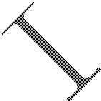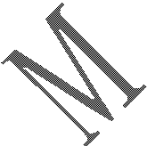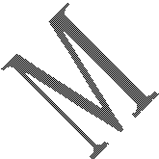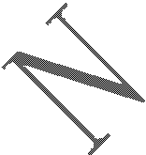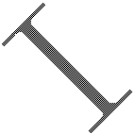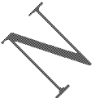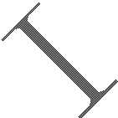

|  |  |
| --- | --- |
|  | * Storage temperature -45°C ~+90°C |
| Data GPRS | * GPRS data downlink transfer: max. 85.6kbps * GPRS data uplink transfer: max. 85.6kbps * Coding scheme: CS-1, CS-2, CS-3 andCS-4 * PAP protocol for PPP connect * Integrate the TCP/IP protocol. * Support Packet Broadcast Control Channel(PBCCH) * CSD transmission rates：2.4，4.8，9.6，14.4kbps |
| CSD | * Support CSD transmission |
| USSD | * Unstructured Supplementary Services Data (USSD)support |
| SMS | * MT, MO, CB, Text and PDU mode * SMS storage: SIM card |
| SIM interface | Support SIM card: 1.8V, 3V |
| External antenna | Antenna pad |
| Audio features | Speech codec modes:   * Half Rate (ETS06.20) * Full Rate (ETS06.10) * Enhanced Full Rate (ETS 06.50 / 06.60 /06.80) * Adaptive multi rate(AMR) * Echo Cancellation * Noise Suppression |
| Serial port and debug port | **Serial port:**   * Full modem interface with status and control lines, unbalanced, asynchronous. * 1200bps to115200bps. * Can be used for AT commands or data stream. * Support RTS/CTS hardware handshake and software ON/OFF flow control. * Multiplex ability according to GSM 07.10 Multiplexer Protocol. * Auto bauding supports baud rate from 1200 bps to57600bps. * upgrading firmware   **Debug port:**   * USB_DM and USB_DP * Can be used for debugging and upgrading firmware. |
| Phonebook management | Support phonebook types: SM, FD, LD, RC, ON, MC. |
| SIM application toolkit | GSM 11.14 Release 99 |
| Real time clock | Support RTC |
| Timing functions | Use AT command set |
| Physical characteristics | Size:15.8*17.8*2.4mm  Weight:1.35g |
| Firmware upgrade | Main serial port or USB port. |

### 3.10.5 Coding schemes and maximum net data rates over air interface

|  |  |  |  |
| --- | --- | --- | --- |
| **Coding scheme** | **1 timeslot** | **2 timeslot** | **4 timeslot** |
| CS-1 | 9.05kbps | 18.1kbps | 36.2kbps |
| CS-2 | 13.4kbps | 26.8kbps | 53.6kbps |
| CS-3 | 15.6kbps | 31.2kbps | 62.4kbps |
| CS-4 | 21.4kbps | 42.8kbps | 85.6kbps |

### 3.10.6 Operating Mode:

The table below summarizes the various operating modes of SIM800L.

|  |  |  |
| --- | --- | --- |
| **Mode** | **Function** | |
| Normal operation | GSM/GPRS SLEEP | Module will automatically go into sleep mode if the conditions of sleep mode are enabling and there is no on air and no hardware interrupt (such as GPIO interrupt or data on serial port).  In this case, the current consumption of module will reduce to the minimal level.  In sleep mode, the module can still receive paging message and SMS. |
| GSM  IDLE | Software is active. Module is registered to the GSM network, and the  module is ready to communicate. |
| GSM TALK | Connection between two subscribers is in progress. In this case, the power consumption depends on network settings such as DTX off/on,  FR/EFR/HR, hopping sequences, antenna. |
| GPRS STANDBY | Module is ready for GPRS data transfer, but no data is currently sent or received. In this case, power consumption depends on network settings and  GPRS configuration. |
| GPRS DATA | There is GPRS data transfer (PPP or TCP or UDP) in progress. In this case, power consumption is related with network settings (e.g. power control level); uplink/downlink data rates and GPRS configuration (e.g. used  multi-slot settings). |
| Power down | Normal power down by sending AT command “AT+CPOWD=1” or using the PWRKEY. The power management unit shuts down the power supply for the baseband part of the module, and only the power supply for the RTC is remained. Software is not active. The  serial port is not accessible. Power supply (connected to VBAT) remains applied. | |
| Minimum functionality mode | AT command “AT+CFUN” can be used to set the module to a minimum functionality mode without removing the power supply. In this mode, the RF part of the module will not work or the SIM card will not be accessible, or both RF part and SIM card will be closed, and the serialportisstillaccessible.Thepowerconsumptioninthismodeislowerthannormal  mode. | |

### 3.10.7 Functional Diagram

The following figure shows a functional diagram of SIM800L:

* + - GSM baseband
    - GSMRF
    - Antenna interface
    - Other interface

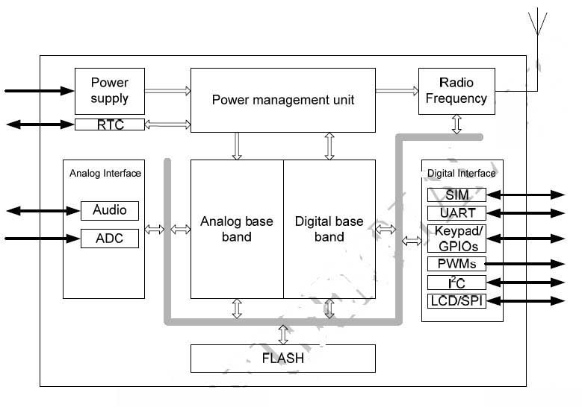

**Fig: Pin out Diagram**

### 3.10.8 Pin Description

|  |  |  |  |  |
| --- | --- | --- | --- | --- |
| **Pin name** | **Pin number** | **I/O** | **Description** | **Comment** |
| **Power supply** | | | | |
| VBAT | 1,42 | I | Power supply |  |
| VRTC | 56 | I/O | Power supply for RTC | It is recommended to connect with a battery ora  capacitor (e.g. 4.7uF). |
| VEXT | 18 | O | 2.8V power output | If these pins are unused,  keep open. |
| GND | 2,6,8,35,37,38,39,  41,43,44,45,58,67  ,71,72,73,76,77,7  8,79,80,81,82,83,  84,85,86,87,88 |  | Ground | GND for VBAT recommend to use 2,43,44,45pin |
| **Power on/down** | | | | |
| PWRKEY | 48 | I | PWRKEY should be pulled low at least 1 second and then released to  power on/down the module. | Internally pulled up to VBAT. |
| **Audio interfaces** | | | | |
| MIC1P | 52 | I | Differential audio input | If these pins are unused, keep open. |
| MIC1N | 12 |
| SPK1P | 53 | O | Differential audio output |
| SPK1N | 13 |
| MIC2P | 9 | I | Differential audio input |
| MIC2N | 10 |
| SPK2P | 51 | O | Differential audio output |
| SPK2N | 11 |
| **PCM interface** | | | | |
| PCMCLK | 29 | O | PCM interface for audio | If these pins are unused, keep open. |
| PCMOUT | 30 | O |
| PCMSYNC | 65 | O |
| PCMIN | 66 | I |
| **Keypads interface** | | | | |
| COL4 | 24 | I | Support up to 50 buttons (5*5*2) | If these pins are unused, keep open. (Pin number 20 external cannot be pulled down） |
| COL3 | 21 | I |
| COL2 | 22 | I |
| COL1 | 25 | I |
| COL0 | 20 | I |
| ROW4 | 63 | O |
| ROW3 | 23 | O |

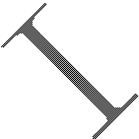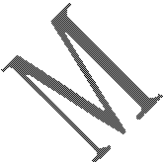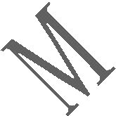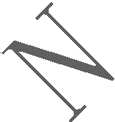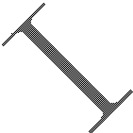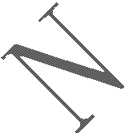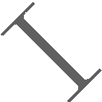

|  |  |  |  |  |  |  |  |
| --- | --- | --- | --- | --- | --- | --- | --- |
| ROW2 | 61 | O |  | | | |  |
| ROW1 | 60 | O |
| ROW0 | 62 | O |
| **GPIO** | | | | | | | |
| GPIO1 | 3 | I/O | Programmable general purpose input and output | | | |  |
| GPIO2 | 27 | I/O |
| GPIO3 | 28 | I/O |
| NETLIGHT | 64 | O | Network status | | | |  |
| STATUS | 4 | O | Power on status | | | |  |
| **Serial port** | | | | | | | |
| UART_DTR | 69 | I | Data terminal ready | | | | If these pins are unused, keep open. |
| UART_RI | 68 | O | Ring indicator | | | |
| UART_DCD | 70 | O | Data carrier detect | | | |
| CTS | 34 | O | Request to send | | | |
| RTS | 33 | I | Clear to send | | | |
| TXD | 32 | O | Transmit data | | | |
| RXD | 31 | I | Receive data | | | |
| **Debug interface** | | | | | | | |
| VBUS | 7 | I | Debug and download | | | | If these pins are unused, keep open. |
| USB_DP | 59 | I/O |
| USB_DM | 19 | I/O |
| **ADC** | | | | | | | |
| ADC | 50 | I | 10bit general  converter | analog | to | digital | If these pins are unused,  keep open. |
| **PWM** | | | | | | | |
| PWM | 26 | O | Pulse-width modulation | | | | If these pins are unused,  keep open. |
| **I2C** | | | | | | | |
| SDA | 75 | I/O | I**2**C serial bus data | | | | Need external pulled up |
| SCL | 74 | O | I**2**C serial bus clock | | | |
| **SIM card interface** | | | | | | | |
| VSIM | 16 | O | Voltage supply for SIM card.  Support 1.8V or 3V SIM card | | | | All signals of SIM interface should be protected against ESD with a TVS diode array. |
| SIM_DATA | 14 | I/O | SIM data input/output | | | |
| SIM_CLK | 55 | O | SIM clock | | | |
| SIM_RST | 15 | O | SIM reset | | | |
| SIMPRE | 54 | I | SIM card detection | | | | Reservation function |
| **Antenna interface** | | | | | | | |
| ANT | 40 | I/O | Connect GSM antenna | | | |  |
| FM_ANT_P | 17 | I | Differential antenna for FM | | | |  |
| FM_ANT_N | 57 | I |
| **Synchronizing signal of RF** | | | | | | | |

|  |  |  |  |  |
| --- | --- | --- | --- | --- |
| BPI_BUS1 | 5 | O | Synchronizing signal of RF |  |
| **Other** | | | | |
| RESET | 49 | I | Reset input(Active low) |  |
| ISINK1 | 46 | I | Drive keypad backlight |  |
| ISINK0 | 47 | I | Drive LCD backlight |  |
| **NC** | | | | |
| NC | 36 |  |  |  |

### 3.10.10 Power Supply

The power supply range of SIM800L is from 3.4V to 4.4V.Recommended voltage is 4.0V.The transmitting burst will cause voltage drop and the power supply must be able to provide sufficient current up to 2A. For the VBAT input, a bypass capacitor (low ESR) such as a 100 µF is strongly recommended.

Increase the 33PF and 10PF capacitors can effectively eliminate the high frequency interference. A 5.1V/500mW Zener diode is strongly recommended, the diode can prevent chip from damaging by the voltage surge. These capacitors and Zener diode should be placed as close as possible to SIM800L VBAT pins.

### 3.10.11 Recommended Zener diode

|  |  |  |  |  |
| --- | --- | --- | --- | --- |
|  | **Vendor** | **Part number** | **Power(watts)** | **Packages** |
| 1 | On semi | MMSZ5231BT1G | 500mW | SOD123 |
| 2 | Prisemi | PZ3D4V2H | 500mW | SOD323 |
| 3 | Prisemi | PZ5D4V2H | 500mW | SOD523 |
| 4 | Vishay | MMSZ4689-V | 500mW | SOD123 |
| 5 | Crown po | CDZ55C5V1SM | 500mW | 0805 |

The following figure is the reference design of +5V input power supply. The designed output for the power supply is 4.1V, thus a linear regulator can be used.

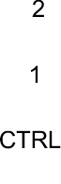

Figure 7: Reference circuit of the DC-DC power supply

The single 3.7V Li-ion cell battery can be connected to SIM800L VBAT pins directly. But the Ni-Cd or Ni-MH battery must be used carefully, since their maximum voltage can rise over the absolute maximum voltage of the module and damage it

When battery is used, the total impedance between battery and VBAT pins should be less than 150mΩ.

The following figure shows the VBAT voltage drop at the maximum power transmit phase, and the test condition is as following:

VBAT=4.0V,

A VBAT bypass capacitor CA=100µF tantalum capacitor (ESR=0.7Ω), Another VBAT bypass capacitor CB=1µF.

## 3.10.12 Power supply pin

Pin 1 and Pin 42 are VBAT input, Pins 2,43,44,45 are GND of power supply, VRTC pin is power supply of the RTC circuit in the module. VDD_EXT output 2.8V when module is in normal operation mode.

When designing the power supply in user’s application, pay special attention to power losses. Ensure that the input voltage never drops below 3.0V even when current consumption rises to 2A in the transmit burst. If the power voltage drops below 3.0V, the module may be shut down automatically. The PCB traces from the VBAT pins to the power supply must be wide enough (at least 60mil) to decrease voltage drops in the transmit burst. The power IC and the bypass capacitor should be placed to the module as close as possible.

### 3.10.13 Monitoring Power Supply

AT command “AT+CBC” can be used to monitor the VBAT voltage. For detail, please refer to document .

### 3.10.14 Power on/down Scenarios

**Power on SIM800L**

User can power on SIM800L by pulling down the PWRKEY pin for at least 1 second and release. This pin is already pulled up to VBAT in the module internal, so external pull up is not necessary. Reference circuit is shown as below.

## 3.11 LCD Display

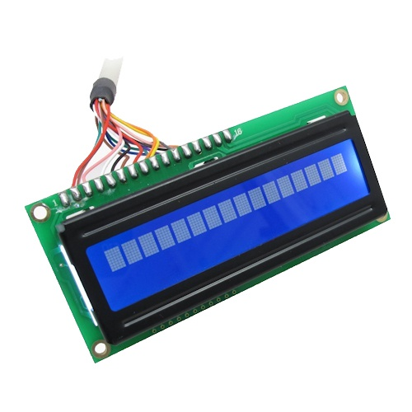

LCD (Liquid Crystal Display) screen is an electronic display module

These modules are preferred over [seven segments](http://www.engineersgarage.com/content/seven-segment-display) and other multi segment [LED](http://www.engineersgarage.com/content/led)s

|  |
| --- |
|  |

LCDs are economical

Construction and Working Principle of LCD Display

What is a LCD(Liquid Crystal Display)?

A liquid crystal display or LCD draws its definition from its name itself. It is combination of two states of matter, the solid and the liquid. LCD uses a liquid crystal to produce a visible image. Liquid crystal displays are super-thin technology display screen that are generally used in laptop computer screen, TVs, cell phones and portable video games. LCD’s technologies allow displays to be much thinner when compared to cathode ray tube (CRT) technology.

Liquid crystal display is composed of several layers which include two polarized panel filters and electrodes. LCD technology is used for displaying the image in notebook or some other electronic devices like mini computers. Light is projected from a lens on a layer of liquid crystal. This combination of colored light with the grayscale image of the crystal(formed as electric current flows through the crystal) forms the colored image. This image is then displayed on the screen.

An LCD is either made up of an active matrix display grid or a passive display grid. Most of the Smartphone’s with LCD display technology uses active matrix display, but some of the older displays still make use of the passive display grid designs. Most of the electronic devices mainly depend on liquid crystal display technology for their display. The liquid has a unique advantage of having low power consumption than the LED or cathode ray tube.

Liquid crystal display screen works on the principle of blocking light rather than emitting light. LCD’s requires backlight as they do not emits light by them. We always use devices which are made up of LCD’s displays which are replacing the use of cathode ray tube.  Cathode ray tube draws more power compared to LCD’s and are also heavier and bigger.

### 3.11.1 How LCDs are Constructed?

Simple facts that should be considered while making an LCD:

The basic structure of LCD should be controlled by changing the applied current.

We must use a polarized light.

Liquid crystal should able be to control both of the operation to transmit or can also able to change the polarized light

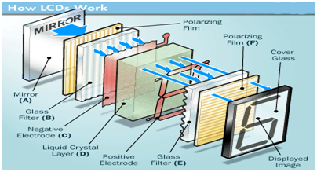

.

As mentioned above that we need to take two polarized glass pieces filter in the making of the liquid crystal. The glass which does not have a polarized film on the surface of it must be rubbed with a special polymer which will create microscopic grooves on the surface of the polarized glass filter. The grooves must be in the same direction of the polarized film. Now we have to add a coating of pneumatic liquid phase crystal on one of the polarized filter of the polarized glass. The microscopic channel cause the first layer molecule to align with filter orientation. When the right angle appears at the first layer piece, we should add a second piece of glass with the polarized film. The first filter will be naturally polarized as the light strikes it at the starting stage.

Thus the light travels through each layer and guided on the next with the help of molecule. The molecule tends to change its plane of vibration of the light in order to match their angle.  When the light reaches to the far end of the liquid crystal substance, it vibrates at the same angle as that of the final layer of the molecule vibrates. The light is allowed to enter into the device only if the second layer of the polarized glass matches with the final layer of the molecule.

### 3.11.3 How LCDs Work?

The principle behind the LCD’s is that when an electrical current is applied to the liquid crystal molecule, the molecule tends to untwist. This causes the angle of light which is passing through the molecule of the polarized glass and also cause a change in the angle of the top polarizing filter. As a result a little light is allowed to pass the polarized glass through a particular area of the LCD. Thus that particular area will become dark compared to other. The LCD works on the principle of blocking light. While constructing the LCD’s, a reflected mirror is arranged at the back. An electrode plane is made of indium-tin oxide which is kept on top and a polarized glass with a polarizing film is also added on the bottom of the device. The complete region of the LCD has to be enclosed by a common electrode and above it should be the liquid crystal matter.

Next comes to the second piece of glass with an electrode in the form of the rectangle on the bottom and, on top, another polarizing film. It must be considered that both the pieces are kept at right angles. When there is no current, the light passes through the front of the LCD it will be reflected by the mirror and bounced back. As the electrode is connected to a battery the current from it will cause the liquid crystals between the common-plane electrode and the electrode shaped like a rectangle to untwist. Thus the light is blocked from passing through. That particular rectangular area appears blank.

### ****3.11.4 Advantages of an LCD’s:****

* LCD’s consumes less amount of power compared to CRT and LED
* LCD’s are consist of some microwatts for display in comparison to some mill watts for LED’s
* LCDs are of low cost
* Provides excellent contrast
* LCD’s are thinner and lighter when compared to cathode ray tube and LED

3.11.5 Disadvantages of an LCD’s**:**

* Require additional light sources
* Range of temperature is limited for operation
* Low reliability
* Speed is very low
* LCD’s need an AC drive

### 3.11.6 Applications of Liquid Crystal Display

* Liquid crystal technology has major applications in the field of science and engineering as well on electronic devices.
* Liquid crystal thermometer.
* Optical imaging.
* The liquid crystal display technique is also applicable in visualization of the radio frequency waves in the waveguide.
* Used in the medical applications.

## 3.12 Main Features of the System

Our intended system provides several advantages as based on a self-healing mesh network to facilitate the removal and injection of nodes during run time. In case of node exclusion due to power shut-down, sudden-stop, or malfunction) its children nodes will automatically find another route to the base node. Other features (depicted in Figure 11) include:

1. Reliability

2. High quality

3. Maintenance free and Hassle free operation

4. Self-healing mesh network configuration

5. Wireless technology, so there is no need for any under construction wiring.

6. Accountability.

7. The possibility to set up the system to send e-mails to the decision makers in case a patient call is not responded to within a predefined time span (example: 3 mins), as shown in Figure 11 of system features.

# CHAPTER 4

## 4.1 Results

Findings were design a new nurse call system for ICU patient, some pictures and videos from patients when using by nurse call system, and analysis questionnaires, that shown in nurse group were 26.7% (8) male and 73.3% (22) female, 75.6% (23) nurses, 6% (3) physicians, 7.6% (2) nurse assistant (Ta b l e 1). In group of patients were 60% male (6) and 40% (4) female. The frequency of scores giving by nurses and physicians’ ideas showed that 28 of them 93.3% were “agree” or “completely agree” to the idea that using nurse call system due to “de- crease patient anxiety and fell of security and about the other questions the nurse call system was accepted by more than 80 percent for majority of questions. Some statements such as “nurse call system attracts more attention” also “pay attention to patients problem & solving problem” had the most score frequency (96.7%). 100% of ideas were “agree” and “completely agree” to the expression “Improvement nurse communication with patient”. The most agree idea was related to “Fast awareness of patient status

The Basic Achievements of Our System Our system has been applied to five patient rooms in a hospital as shown in Figure 1, where we have successfully implemented our system and completely tested all its functions and features. Each patient room had a wireless nurse call unit as shown in Figure 12. By pressing the button it triggers the signal alarm in the nurse station through the Gateway unit as shown in Figure 13. Real-time readings were securely uploaded to the Raspberry Pi boards which are accessible from the nurse desktop device or even from the technical desktop device as shown in Figure 15 a and Figure 15 Figure 15 a showing the normal case when No patient is demanding any help or medical assistant & Figure 15 b is showing that patient Room # 5 is asking for Nurse support. Our system is flexible & customized so it could be retuned according to the client demands. Each node in the network presented itself to the controller at the initial login and then the controller responded with a login confirmation. The controller broadcast periodically a network discovery order. Each node responded with its current parent and the number of hoops to the controller. The controller used this information to build the current network topology as shown in Figure 16. In the end, our proposed system succeeded in displaying and monitoring our five patient room prototype (in the Complex Army Medical center in Kobry El Koba). So, it is now ready to be installed in any clinical center as it can manage up to 254 patient rooms in any hospital or medical center with the flexibility given to the customer for any alteration or tuning in the data base or screening monitors or even for adding additional features.

## 4.2 DISCUSSION

We did not find similar studies that worked on nurse call system for ICU patient, but the kinds of systems that like this study surveyed, and we compared them with our system. In one survey “wireless communication system” installed at St Agnes Hospital by Vocera Communica- tions. This system enables connectivity between third- part systems as a nurse call system. The system de- creased “average time a patient requests” about 51% in all of observations. The results their study have shown that using communications system reduced overall mean time, especially when the needs were serious and urgent [ 12]. In addition, Ultra Phoenix is another nurse call sys- tem that uses a touch-screen computer. In this system, use acentral LCD and two-speakers or microphone (for situations that they do not want the speaker to use). Another one system was “Intego Systems Inc” that in this system Patients contacted by a communication net- work with hospital nurses [ 13], and in other nurse call system reported two part including: I. Central monitor nurse call display; II. CMU-02 that it was wirelessly pieces, that patients to carry it. Patients can bring it, when necessary, and in this state patient situation will be determined in the nursing station, and Nurses can help patients [ 14]. Spetz and others wrote in their study, that risk of patient falls from bed is very important because it increases mortality and morbidity in hospital. In order to reduce these problems, they used system nurses call in Neurosurgery. Their system consists of two parts: 1) Antenna and a sensor installed near the patient had; 2) A bedside unit that was attached nurse call system. Their findings showed that rates of falling out of bed were reduced, and they reported about reduce cost effectiveness in hospital [ 15]. The aim of our study was to design and build a system to help ICUs’ patients, and other aim was patients communicate with others when they have intubation or tracheostomy tubes, but they are alert. We did not deter- mined the rate of patient’s falling or response time to request, but patient satisfaction evaluated, and the results showed that patient satisfaction increased by using nurse call system.

## 4.3 Advantages

Main advantages of this projects

* 1. Patient can easily contact to nurse.
  2. Medical authority can monitoring activities of nurses.
  3. Patient no need to go to nurse room.

## 4.4 Limitations

* Create a communication gap due to error mobile network.
* Irregular body movement.
* Limited Automated Monitoring.
* Smaller Scale Industrial Monitoring.

## 

## 4.5 Applications

1. HVAC (Heating, Ventilation and Air Conditioning) Systems
2. Weather Stations
3. Medical Equipment for measuring humidity
4. Home Automation Systems
5. Automotive and other weather control applications
6. We can use this kind of project in such kind of farm where always need a constant temperature.
7. We can use it also in agricultural research.
8. In Industries.

.

# 

# CHAPTER 5

## 5.1 Future Work

In the near future we seek to produce more systems (at the mass production scale), in order to decrease all the human errors and to increase the safety levels in the healthcare buildings. Also since our system is computer interfaced and modular, it can be easily upgraded to send sms and e-mails. Research may also continue to develop more efficient and intelligent systems that will be able to take actions and make decisions according to prescribed scenarios.

## 5.2 Conclusions

In this papers, we present a new proposed model for SP, where this patients cannot move their bodies except hands. We build this system to read hands movements and translate this movements to requests carried out by doctors. The future HGDR is very bright especially for disabled patients and SP. This technique is natural and easy way to make a contact with a machine (simulation), where the user not needing the training phase . This technique can be made a wireless technique, especially faraway patients. At this time, this technique can be controlled remotely. So in any case of disaster like fires or earthquake, if the person is in danger and can’t get a help, he can show HG syntax to the system that will interpret it and send it as a signal to transceiver nearby and it will forward the signal further to the rescue team in the control room. This system can be development by adding Global Positioning System. This way help the persons to detect there locations by rescue team.

Our intended system utilizes wireless technology because there is no need to install cables to any of the call points, and the impact is minimal as shown in Figure 1 explaining system configuration. Wireless systems also have lower installation and operating costs over a traditional hard-wired system, as well as being quicker and easier to install. Wireless configuration offers complete flexibility and mobility, which makes our system infinitely changeable and expandable, thus allowing for the constant ability to deal with ever changing priorities and demands. Additionally, our system is safe, reliable and cost-effective. It can be designed to suit individual requirements and needs and adapted to work within any hospital budget. It also has a variety of features which can help to maximize staff efficiency and improve the overall quality of care offered to health care clients and patients. Our intended system proved successful at performing its main function. It also featured a fast response time in case of a pressure fault problem. The result was indeed an amazing system without any human errors. Also the Research and Development (R&D) carried out for the gas monitoring system gives the opportunity to any developing team to build a complete control system, as well as to try to reach a high level of technology at the international market scale.

Appendix A

#include<LiquidCrystal.h>

LiquidCrystal lcd(12,11,10,9,8,7);

#define TEMPIN A0

#define EPIN A3

#define B1PIN A4

#define B2PIN A5

#define B3PIN A6

#define B4PIN A7

#define BUZ 13

#define FAN 2

#define X0PIN 3

#define X1PIN 4

#define Y0PIN 5

#define Y1PIN 6

int tp;

void setup()

{

lcd.begin(16,2);

pinMode(BUZ, OUTPUT);

pinMode(FAN, OUTPUT);

pinMode(TEMPIN, INPUT);

pinMode(B1PIN, INPUT);

pinMode(B2PIN, INPUT);

pinMode(B3PIN, INPUT);

pinMode(B4PIN, INPUT);

pinMode(X0PIN, INPUT);

pinMode(X1PIN, INPUT);

pinMode(Y0PIN, INPUT);

pinMode(Y1PIN, INPUT);

lcd.setCursor(0,0);

lcd.print(" WELCOME TO ");

lcd.setCursor(0,1);

lcd.print(" CITY UNIVERSITY ");

delay(1500);

lcd.setCursor(0,0);

lcd.print(" SUBMITTED BY ");

lcd.setCursor(0,1);

lcd.print(" ");

delay(1500);

lcd.setCursor(0,0);

lcd.print(" ARIF ");

lcd.setCursor(0,1);

lcd.print(" SHAON ");

delay(2500);

lcd.clear();

lcd.print("Circuit Digest");

delay(1000);

lcd.setCursor(0,1);

lcd.print("System Ready");

SendMessage();

}

////////////////////////////////////////////////////////////////////////////

////////////////////////////////////////////////////////////////////////////

void loop()

{

SENSOR();

DISPLAY1();

CONTROL();

}

///////////////////////////////////////////////////////////////////////////////

///////////////////////////////////////////////////////////////////////////////

void DISPLAY1()

{

lcd.setCursor(0,0);

lcd.print("T:");

lcd.setCursor(2,0);

lcd.print(tp);

lcd.setCursor(5,0);

lcd.print((char)223);

lcd.setCursor(6,0);

lcd.println(" C ");

delay(1);

}

///////////////////////////////////////////////////////////////////////////////

void SENSOR()

{

B1SW = analogRead(B1PIN);

B2SW = analogRead(B2PIN);

B3SW = analogRead(B3PIN);

B4SW = analogRead(B4PIN);

tp = analogRead(TEMPIN);

EMERGENCY=analogRead(EPIN);

Y0PIN= digitalRead;

Y1PIN= digitalRead;

X0PIN= digitalRead;

X1PIN= digitalRead;

}

///////////////////////////////////////////////////////////////////////////////

void CONTROL( )

{

//////////////////////////////

if(B1SW < 250)

{

almstp =1;

SendMessage1();

alarm();

}

if(B2SW < 250)

{

almstp =2;

SendMessage2();

alarm();

}

if(B3SW < 250)

{

almstp =3;

SendMessage3();

alarm();

}

if(B4SW < 250)

{

almstp =4;

SendMessage4();

alarm();

}

//////////////////////////////

if(tp > 42)

{

almstp =5;

SendMessage9();

alarm();

}

if(EMERGENCY < 250)

{

almstp =6;

SendMessage12();

alarm();

}

if(tp > 34)

{

digitalWrite(FAN, HIGH);

}

if(tp < 33)

{

digitalWrite(FAN, LOW);

}

}

////////////////////////////////////////////////////////////

void alarm()

{

if(almstp==1)

{

lcd.setCursor(0,1);

lcd.print("BED-1 CALLING...");

}

if(almstp==2)

{

lcd.setCursor(0,1);

lcd.print("BED-2 CALLING...");

}

if(almstp==3)

{

lcd.setCursor(0,1);

lcd.print("BED-3 CALLING...");

}

if(almstp==4)

{

lcd.setCursor(0,1);

lcd.print("BED-4 CALLING...");

}

if(almstp==5)

{

lcd.setCursor(0,1);

lcd.print("FIRE DETECTED ");

}

if(almstp==6)

{

lcd.setCursor(0,1);

lcd.print("EMERGENCY ");

}

if(almstp==7)

{

lcd.setCursor(0,1);

lcd.print("NEED MEDICINE ");

}

if(almstp==8)

{

lcd.setCursor(0,1);

lcd.print(" NEED WASH ");

}

if(almstp==9)

{

lcd.setCursor(0,1);

lcd.print(" COME HERE ");

}

if(almstp==9)

{

lcd.setCursor(0,1);

lcd.print(" NEED WATER ");

}

}

////////////////////////////////////////////////////////////

void SendMessage()

{

Serial.println("AT+CMGS=\"+8801817240568\"\r");

Serial.println("system ready...");

}

void SendMessage1()

{

Serial.println("AT+CMGS=\"+8801817240568\"\r");

Serial.println("BED-1 CALLING...");

}

void SendMessage2()

{

Serial.println("AT+CMGS=\"+8801817240568\"\r");

Serial.println("BED-2 CALLING...");

}

void SendMessage3()

{

Serial.println("AT+CMGS=\"+8801817240568\"\r");

Serial.println("BED-3 CALLING...");

}

void SendMessage4()

{

Serial.println("AT+CMGS=\"+8801817240568\"\r");

Serial.println("BED-4 CALLING...");

}

void SendMessage5()

{

Serial.println("AT+CMGS=\"+8801817240568\"\r");

Serial.println("FIRE DETECTED");

}

void SendMessage6()

{

Serial.println("AT+CMGS=\"+8801817240568\"\r");

Serial.println("EMERGENCY");

}

void SendMessage7()

{

Serial.println("AT+CMGS=\"+8801817240568\"\r");

Serial.println("NEED MEDICINE ");

}

void SendMessage8()

{

Serial.println("AT+CMGS=\"+8801817240568\"\r");

Serial.println(" NEED WASH ");

}

void SendMessage9()

{

Serial.println("AT+CMGS=\"+8801817240568\"\r");

Serial.println(" COME HERE ");

}

void SendMessage10()

{

Serial.println("AT+CMGS=\"+8801817240568\"\r");

Serial.println(" NEED WATER ");

}

***REFERENCES***

1. The European Standard (ISO 7369), issued in Nov 2016.

1. The United State of America Standard (NFPA 99). 2008-2017.
2. Drug portion of (21) of the Code of Federal Regulations (CFR). Dec 2009.
3. “Wen Li, Sami Kara”, “Methodology for Monitoring Manufacturing Environment by Using Wireless Sensor Networks (WSN) and the Internet of Things (IoT)”; Procedia CIRP 61 ( 2017 ) 323-328 published in 2017.
4. Adel S. Sedra and Kenneth C. Smith, (Feb. 2008), “Microelectronic Circuits”, Fifth Edition and Laboratory Explorations (Oxford Series in Electrical & Computer Engineering).
5. Mitchel Schultz, (Apr 2010), “Problems Manual to accompany Grob's Basic Electronics”.
6. “NPpocket Nursing” Book, 1st edition, issued in 2017; ISBN-13: 978-1943991693.
7. “ATMEL Wireless Production Test Reference”; 42253A−WIRELESS−03/2014, issued in 2014.
8. “Wireless Mobility Controller System Reference Guide”; Software Version 5.5; Part number: 120870-00 ; published in march 2014.
9. Nick Dossis, “Basic Electronics for Tomorrows Inventors”, (Dec 2011). [11] EN 475, “Medical devices - Electrically-generated alarm signals”, (June 2011).
10. “Atmel studio” reference guide; Atmel-42167B-AtmelStudio_User Guide-09/2016; issued in 2016.
11. “Atmel studio 7 user guide”; ISBN: 978-1-5224-2614-1; issued in 2018.
12. “Swagata Devi ,Soumik Roy”, “Physiological measurement platform using wireless network with Android Application”; Informatics in Medicine Unlocked 7 (2017) 1-13; published in 2017.
13. “Geert Roelf Kleve “, “How safe is our nurse call system“; 4th European STAMP workshop 2016; Procedia Engineering 179 (2017) 34- 40; published in 2017.
14. “Jaillah Mae Gesulgaa, Almarie Berjameb, Kristelle Sheen Moquialac, Adrian Galidod “, “Barriers to Electronic Health Record System Implementation and Information Systems Resources: A Structured Review”; 4th Information Systems International Conference 2017, ISICO 2017, 6-8 November 2017, Bali, Indonesia; Procedia Computer Science 124 (2017) 544-551 published in 2017.
15. B. Peng and G.Qian, “ Online gesture spotting from visual hull data,” IEEE Trans. on Pattern Analysis and Machine Intelligence, vol. 33, no. 6, pp. 1175–1188, 2011.
16. S. Mitra and T. Acharya, “Gesture Recognition: a survey,” IEEE transactions on systems, man, and cybernetics-part C: applications and review, vol. 37, no. 3, pp. 2127-2130, May 2007.
17. J. Davis and M. Shah, “Recognizing Hand Gestures,” in Proceedings of European Conference on Computer Vision, Stockholm, Sweden, 2-6 May 1994, pp. 331-340.
18. Y. T. Chen and K. T. Tsengn, “Developing a multiple-angle hand gesture recognition system for human machine interactions,” in Proceedings of 33rd Annual Conference of the IEEE industrial Electronics Society, Taipei, Taiwan, 5-8 Nov. 2007, pp. 489-492.
19. N.Papamarkos , E.Stergopoulo and N.Papamarkos, “A New Technique on Hand Gestures Recognition”, Proc of the IEEE International Conference on Image Processing, 2657-2660, 2006.
20. X. Liu and K.Fujimura, “Hand Gesture Recognition using Depth Data”, Proc. of the Sixth IEEE International conference on automatic Face and Gesture Recognition, p.p. 529-534, 2004.
21. Graupe, Daniel, (2007):”Principles of Artificial Neural Networks”, Second edition, World Scientific Publishing Co. Singapore.
22. Hagan, Martin T., Demuth, Howard B., Beale, Mark, (1996):”Neural network Design”, Pws Publishing Co., USA .
23. H.M. ,Md. Sahil, Md. Sham., “BPN Learning Algorithm for Error Tolerance ET - A Proposed Algorithms for Multilayer Neural networks”, ICCIT-2005.
24. A. Torige and T. Kono, “Human-Interface by Recognition of Human Gestures with Image Processing, Recognition of Gesture to Specify Moving Directions,” IEEE international Workshop on Robot and Human Communication, Tokyo, Japan, 1-3 Sep. 1992, pp. 105-110.
25. H. Lu ,Yikai Fang , K. Wang and J. Cheng. “Hand Gestures Recognition Using Fast Multi-scale Analysis”, Proc. of the Fourth International Conference on Image and Graphics, p.p 694-698 , 2007.
26. T. Lindeberg , L. Bretzner, and I. Laptev, “Hand Gesture using multi-scale color features, hierarchical models and particle filtering”, Proc. of the Fifth International conference on Automatic Face and Gesture Recognition, p.p. 423- 428, 2003.
27. T. Siranyi and A. Licsar. “Supervised training based hand gestures recognition system”, Proc. of the 16th International Conference on Pattern Recognition, Vol. 3, p.p 30999 – 31003, 2002.
28. H. Sumi, K. Hoshino, and T.Nish., "Noise detection and reduction for image sensor by time domain autocorrelation function method", IEEE Proceedings of (ISICE), 2007. [15] S. Mitra and T. Acharya, “Gesture Recognition: a survey,” IEEE transactions on systems, man, and cybernetics-part C: applications and review, vol. 37, no. 3, pp. 2127-2130, May 2007.
29. S. Ahn, J. Kim, J. Kwak, J. Kim and D. H. Kim, “Augmented Interface Table based on Fingertip Recognition for Embedded Devices,” in Proceedings of 8th ICACT 2006, 20-22 Feb. 2006, pp.1843-1847.
30. A. Chaudhary and J. L. Raheja, “A Formal Approach for Agent based Large Concurrent Intelligent Systems,” International Journal of Advanced Engineering Technology, vol. 1, pp. 95-103, April-June 2010